Garlic Spinach/Greens
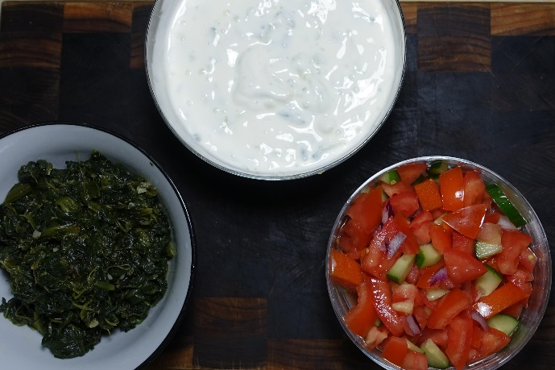
Ingredients
1 teaspoons oil
3 cloves of garlic finely sliced, or equivalent
1 bunch of greens, spinach or asian greens or a ½ bag of Logan Farm Spinach portions
1 teaspoon butter
Pinch of salt to taste
Method
- Heat the oil and add the finely sliced garlic and cook till the garlic is brown and starting to get crispy
- the mustard seeds and curry leaves and cook on a low-medium heat for a few minutes till Portion plating
- Add the Spinach/Greens and cook till just tender which will take a few minutes. If using fresh spinach turn the heat down and put the lid on as this will take 5-10 minutes to defrost
- Add the butter and salt and stir well to ensure mixed

